The Pharmaceutical industry in the Global Economy

Summer 2005

Larry Davidson*
and
Gennadiy Greblov

Indiana University Kelley School of Business
Bloomington, Indiana

*Davidson is Professor of Business Economics and Public Policy and Greblov is working towards his MBA degree at the Kelley School of Business

Prepared for the Indiana Economic Development Corporation with the support of the Center for International Business Education and Research at the Indiana University Kelley School of Business. Information Services via the World Trade Atlas, U.S. State Export Edition.
To receive free copies of the export report please contact the Indiana Economic Development Corporation’s Office of International Trade at 317.232.4949. Direct questions to the authors of the report to Larry Davidson at davidso@indiana.edu or 812.855.2773.

Introduction

This paper summarizes the results of our global pharmaceutical industry analysis and is intended to increase awareness of the general public – investors, policy makers, managers, employees of the companies – about its current developments. The paper has the following major goals:
- To analyze the current situation, major challenges and the prospects of the pharmaceutical industry;
- To identify major players of the global pharmaceutical industry and make a comparative analysis of their business practices and financial results;
- To determine the relative position of the U.S. pharmaceutical companies in the global pharmaceutical industry, as well as to reveal opportunities for further strengthening of their positions.

The paper consists of three major parts. In the first part we present an overview of the pharmaceutical industry as a whole – its major players, current trends and challenges. The second part focuses on a more detailed analysis of major pharmaceutical companies. These major companies are divided into two major groups: a) companies with headquarters in the U.S., b) foreign pharmaceutical companies with headquarters outside of the U.S. Pharmaceutical companies are compared with other companies in the same group; and major trends within each group are analyzed. Part 3 sums up our findings.

Part 1. Pharmaceutical industry overview.

Major players of the world pharmaceutical industry

The pharmaceutical industry is characterized by a high level of concentration with fifteen multinational companies dominating the industry. Table 1.1 contains information about these major pharmaceutical companies that are sorted in the order of their 2004 revenues from the sales of pharmaceutical products. Numbers provided in this table include sales of all subsidiaries and affiliated companies that are consolidated in annual reports of the corresponding companies. In order to facilitate a comparison of different companies revenues of all of them are shown in US dollars; financial data of the companies with headquarters outside of the U.S. was converted to US dollars using average 2004 rates provided in Table 1.2.
Table 1.1. Major pharmaceutical companies.
Company | HQ location | Revenue of pharmaceutical segment, mln USD | Total sales, mln USD | Share of pharmaceutical segment, %
Pfizer | NY, U.S. | 46,133 | 52,516 | 87.85%
GlaxoSmithKline | UK | 31,434 | 37,324 | 84.22%
Johnson & Johnson | NJ, U.S. | 22,190 | 47,348 | 46.87%
Merck | NJ, U.S. | 21,494 | 22,939 | 93.70%
AstraZeneca | UK | 21,426 | 21,426 | 100.00%
Novartis | Switzerland | 18,497 | 28,247 | 65.48%
Sanofi-Aventis | France | 17,861 | 18,711 | 95.46%
Roche | Switzerland | 17,460 | 25,168 | 69.37%
Bristol-Myers Squibb | NY, U.S. | 15,482 | 19,380 | 79.89%
Wyeth | NJ, U.S. | 13,964 | 17,358 | 80.45%
Abbott | IL, U.S. | 13,600 | 19,680 | 69.11%
Eli Lilly | IN, U.S. | 13,059 | 13,858 | 94.23%
Takeda | Japan | 8,648 | 10,046 | 86.09%
Schering-Plough | NJ, U.S. | 6,417 | 8,272 | 77.57%
Bayer | Germany | 5,458 | 37,013 | 14.75%
Source: 2004 Annual Reports of the companies

As Table 1.1 shows, the majority of the largest pharmaceutical companies are not diversified. They are either concentrated exclusively on pharmaceutical products (Eli Lilly and AstraZeneca are good examples with virtually 100% of their revenues coming from sales of pharmaceutical products) or, although they develop and manufacture other health care products, they still have pharmaceutical divisions as the core of their business that provide more than 50% of their revenues. Other products manufactured by these companies usually include medical devices, nutritional products, consumer healthcare products and products for animal health.

Only two out of these 15 major pharmaceutical companies have revenues from sales of pharmaceutical products that are lower than 50% of their total sales. These companies are world giants Johnson & Johnson (which besides pharmaceutical products manufactures consumer goods and medical devices) and Bayer which has only about 15% of its revenues from the sales of pharmaceutical products.

Eli Lilly’s $13.1 billion sales figure made it the twelfth largest company – with Pharmaceutical sales considerably larger than Bayer’s $5.5 billion but a lot less than Pfizer’s $46.1 billion.

Geographical headquarters of major pharmaceutical companies are approximately evenly distributed between the U.S. and Western Europe with only one Asian company in the list. Indiana is home to one of these companies, Eli Lilly. More detailed analysis of these companies will be made in the second part of this paper.

Table 1.2. Average 2004 exchange rates.
Currency | Exchange rate
EUR / USD | 1.2438
GBP / USD | 1.8333
USD / JPY | 108.1508
USD / CHF | 1.2426
Source: calculated using Federal Reserve daily data

Industry Trends

Here we examine structural changes causing significant transformations, major factors leading to strong future sales growth, and point out the industry’s strong reliance on research and development.

Structural changes

The pharmaceutical industry is currently undergoing a period of very significant transformation. The majority of “Big Pharma” companies generate high returns, thus providing them with excess cash for further rapid growth – whether organic, or through mergers and acquisitions. Although size of the company on its own does not guarantee success, it gives a significant advantage, especially in pharmaceutical industry. Besides economies of scale in manufacturing, clinical trials and marketing, bigger companies can allow investments in more research and development (R&D) projects that diversify their future drugs portfolio and make them much more stable in the long term. As the result, top-companies in the industry were active participants of mergers and acquisitions (M&A), new joint ventures and spin-offs of non-core businesses.

The largest acquisitions in the industry during last years were the acquisition of Pharmacia by Pfizer (purchase price $58 billion), and acquisition of Guidant by Johnson & Johnson (purchase price $25 billion). Both acquisitions allowed these two U.S.-based companies to solidify their places among the elite of the pharmaceutical industry. European companies were even more aggressive in M&A activity than their American competitors – 3 out of 6 major European companies underwent mergers during the last several years: GlaxoSmithKline (merger of Glaxo Wellcome and SmithKline Beecham), AstraZeneca (merger of Astra and Zeneca) and Sanofi-Aventis (merger of Sanofi-Synthelabo and Aventis).

Another form of structural change in the industry was establishing of new strategic alliances and joint ventures. So far as the research and development process for each drug take many years and requires significant investments, and the outcome of these investments of time and financial resources remains unclear until the final approval of the drug, “Big Pharma” companies are constantly looking for synergies that they can get from cooperation with their competitors. Last years gave multiple examples of such initiatives. For example, cooperation of Sanofi-Aventis and Bristol-Myers Squibb resulted in production of Plavix, which is currently one of the top-selling products for each of these companies.

Finally, “Big Pharma” companies in order to maintain strong sales growth and meet profitability expectations of their shareholders were actively selling low-profitability or non-core businesses. For example, in 2003 Merck sold its low-profitability Medco Health Solutions that helped to increase its profitability margin. Massive sales of non-pharmaceutical businesses by Takeda also were compatible with its strategy to concentrate its financial resources on its core pharmaceutical business.

Major factors of future growth

The pharmaceutical industry showed high sales growth rates in the recent past, and a number of factors suggest that this trend will continue in the future.

First, due to numerous advancements in science and technology, including those in the health care industry, life expectancy in the developed countries has been steadily growing. As the result, growing proportion of elderly people promises further growth of demand for healthcare products.

Moreover, according to various studies, a significant portion of elderly population in the United States and other countries does not receive proper treatment. For example, only about one third of the U.S. population who requires medical therapy for high cholesterol is actually receiving adequate treatment. As it is expected, the Medicare Prescription Drug Improvement and Modernization Act starting from the beginning of 2006 will increase access of senior citizens to the prescription drug coverage, thus increasing pharmaceutical sales.

Although developing countries at the moment have a small portion of world pharmaceutical sales, these countries also have a significant potential for the pharmaceutical industry in the future. Fast growing economies in Asia, South America and Central & Eastern Europe suggest an increasing solvency of population and make these markets more and more attractive for “Big Pharma” companies. Further reforms of legislation systems in the countries of these regions, especially regarding patent protection issues, will inevitably result in growing pharmaceutical sales.

Strong emphasis on R&D

One of the distinctive characteristics of the “Big Pharma” companies is a very high level of investments in research and development. On average, it takes about 10-15 years, and millions of dollars to develop a new medicine. According to industry statistics, only about one in ten thousand chemical compounds discovered by pharmaceutical industry researchers proves to be both medically effective and safe enough to become an approved medicine, and about half of all new medicines fail in the late stages of clinical trials. Not surprisingly, according to “Research and Development in Industry: 2001” report of the National Science Foundation, in 2001 the pharmaceutical industry had one of the highest R&D expenditures as percentage of net sales. More detailed information on this issue is provided in the second part of this paper.

Key Challenges

The main challenges for drug companies come from four areas. First, they must deal with competition from within and without. Second, they must manage within a world of price controls that dictate a wide range of prices from place to place. Third, companies must be constantly on guard for patent violations and seek legal protection in new and growing global markets. Finally, they must manage their product pipelines so that patent expirations do not leave them without protection for their investment.

Competition

The pharmaceutical industry currently represents a highly competitive environment. One can distinguish three layers of competition for “Big Pharma” companies:

First, obviously, “Big Pharma” companies compete among themselves. Although not all leading pharmaceutical companies cover all segments of pharmaceutical market, almost all of them are active in R&D and production of drugs in the segments with the highest potential – such as treatment of infectious, cardiovascular, psychiatric or oncology diseases.

Secondly, “Big Pharma” companies experience significant profit losses due to competition from the generic drug manufacturers. Opposite to the research-oriented pharmaceutical companies, which invest significant financial resources and time to develop new medicines, generic drug manufacturers spend minimum resources on R&D, and start manufacturing already developed by other companies drugs after their patent expiration. Because generic drug manufacturers do not have to recoup high R&D costs, prices of their products are usually much lower then those of major pharmaceutical companies; as the result, after patent expiration, generic drugs manufacturers capture significant market share, dramatically decreasing revenues of the “Big Pharma” companies.

Finally, the whole pharmaceutical industry competes with other health care industries. In this case, pharmaceutical companies should not only demonstrate high efficiency of their products, but also provide obvious proof of cost advantages in comparison with other forms of care.

Price control

Pharmaceutical companies have to operate in a highly regulated environment; the degree of regulation to a significant extent depends on the country and type of the product.

One of the most important aspects of government regulation for pharmaceutical companies is price regulation, and different countries have different policies on this issue.

In the United States – the largest and the most attractive pharmaceutical market – currently there is no direct price control for non-government drug sales. At the same time, it is expected that Medicare Prescription Drug Improvement and Modernization Act will potentially increase downward price pressure.

The majority of European countries control drug prices, and this downward pressure on prices has been increasing during last years. Japan has even stricter price controls than European countries; all prices are controlled by the government, and they are subject to a periodic price review.

As the result of price control, prices of the same products can significantly differ in different countries.

Protection of patents

Generic drugs manufacturers represent a significant threat to research-based pharmaceutical companies. For example, Schering-Plough’s Claritin patent expired in 2002; as the result of generic drug competition, sales of Claritin by Schering-Plough declined from $3.2 billion in 2001 to $1.8 billion in 2002 and to $0.37 billion in 2003.

Moreover, generic drugs manufacturers sometimes start production of patent-protected drug analogues even before a patent expires. Although research-oriented companies in many cases are able to protect their patents, they do suffer from lost revenues.

Therefore, protection of patents is one of the key conditions necessary for further development of the pharmaceutical industry. At the same time, non-efficient legislation that does not provide the necessary level of patent protection is one of the factors that hamper expansion of “Big Pharma” companies to the developing countries.

Drugs portfolio management

Drug portfolio management is one of the most important determinants of long-term prosperity of research-oriented pharmaceutical companies.

First, it takes an extremely long time to develop a new drug, and only a very small portion of all projects is successful. Projects that the company starts today will determine its financial performance 10-15 years later. Therefore, careful planning of R&D projects is very important for the long-term stability of the company.

Second, insofar as patents keep exclusivity of drugs only during a limited time, and soon after the expiration of the patent the sales of the drug sharply go down, the company has to carefully monitor its patent expiration dates, and insure that new products become available by that date. Otherwise, we are reminded of the case of Shering-Plough, when after expiration of its major drug patent the company did not have a new product of similar value and the company experienced losses in 2003 and 2004.

Definitely, planning errors or rapidly changing demand in the industry can be corrected by acquisition of smaller research companies or patents from competitors, but in any of these cases the company will have to pay a premium price, thus reducing its profitability.

Prospects for international expansion

According to IMS Health as restated in the 2004 AstraZeneca Annual Report, the United States, the European Union and Japan comprise the three major pharmaceutical markets which together represent 88% of world sales; and the U.S. market alone accounts for about 47% of world sales. Not surprisingly, all “Big Pharma” companies to a significant extent concentrate their resources on these markets, especially on the U.S. market.

At the same time, although the share of world pharmaceutical sales in developing countries at this point of time is much lower, they show much faster growth rate than developed countries do. For example, the China, 9th largest world market, showed a 26% sales increase in 2004, followed by Thailand (16% growth) and Egypt (15%). Some Latin American countries, such as Mexico, Brazil, Argentina and Venezuela also show much faster sales growth rate than average worldwide. Therefore, developing countries contain a significant potential for further expansion of pharmaceutical industry in the future.

Indiana in the World Market for Pharmaceuticals

In 2004 Indiana’s Pharmaceutical exports reached $971 million. That made it Indiana’s sixth largest export industry – accounting for about 5% of all Indiana exports. Between 2002 and 2004, Indiana Pharmaceutical exports increased by $425 million – an increase of 78%. The key components are described as medications, hormones, and antibiotics. Indiana exports most of these products to Europe – the leading destinations in 2004 were France, Spain, the UK, and Germany. Those four countries took almost 59% of Indiana’s Pharmaceutical exports that year. The remaining top 10 destinations were Canada, the Netherlands, Switzerland, Ireland, Mexico, and Austria. Indiana’s Pharmaceutical export profile is very similar to the nation’s – the United States and Indiana are almost totally focused on NAFTA partners and Europe.

Who buys the world’s Pharmaceutical products? The United Nation’s Statistics Division publishes annual values for Pharmaceutical imports and exports for most countries. The key world importers include the United States and Europe. Below we report statistics for 2003 for these two areas as well as for other key areas and countries. There are several things to note from this table. First, the United States is the largest importer of Pharmaceutical products followed by EU15 (the fifteen countries that comprised the European Union before the recent expansion to 25 countries) and Switzerland. Japan and Canada are important destinations but each import less than Switzerland. China imported less than $2 billion in 2003 but remains an interesting destination because of its remarkable growth and development.

Table 1.3. Pharmaceutical industry – international trade
Importer | 2003 imports, thousands | Exporter
USA | 31,739,624 | 79% from Europe; 13% from Asia; 7% from North America
EU15 | 28,351,731 | 52% from North American; 35% from Europe
Switzerland | 9,718,628 | 88% from Europe; 10% from North American
Japan | 6,193,127 | 69% from Europe; 23% from North America
Canada | 6,064,628 | 49% from Europe; 48% from North America
China | 1,705,632 | 65% from Europe;8% from North America
Table note: These data refer to Standard Industrial Trade Classification (SITC Rev: 3) data for codes 54.1 and 54.2. These two codes cover what is traditionally thought of as Pharmaceutical products. EU15 refers to the 15 members of the European Union – those that were members before the increase to 25 members. Europe refers to a very large and wide definition of countries in western and east/central Europe. Switzerland is part of Europe but is not a member of the EU. The data is in thousands of dollars.

The next table shows the largest changes that occurred in Pharmaceutical imports between 1995 and 2003. The largest change was the almost $22 billion increase of imports to the United States from Europe. The United States also received large inflows of Pharmaceutical products from Asia ($3.5 billion) and North America ($1.9 billion). EU15 also shows up three times in the table with a total of about $28 billion – from N. America, Europe, and Asia. Canada has two entries showing increased Pharmaceutical imports from Europe ($2.5 billion) and the N. America ($2 billion). Switzerland, Japan, and China’s largest imports came from Europe.

Table 1.4. Changes in pharmaceutical imports between 1995 and 2003, dollar change
Imports to | Imports from | Dollar Change In thousands, 1995 to 2003
USA | Europe | 21,968,851
EU15 | N. America | 14,786,491
EU15 | Europe | 10,041,165
Switzerland | Europe | 6,853,882
USA | Asia | 3,518,057
EU15 | Asia | 3,024,816
Canada | Europe | 2,465,464
Canada | N. America | 1,969,847
USA | N. America | 1,904,983
Japan | Europe | 1,601,565
China | Europe | 859,540

While the above table shows where most of the goods are going, the next one features the hot flows – those that have grown the fastest between 1995 and 2003. Notice that this list is a lot different from the one above. Japanese imports from Africa showed huge percentage growth, as did China’s imports from Central & South America and Africa. The United States is listed four times with triple digit import growth from Europe, North America, Asia, and Oceana. It is interesting that Europe15 is not on this list. Switzerland is mentioned once with rapidly growing imports from Asia.

A look at the second column is instructive. Africa shows up three times – suggesting that Africa is becoming a more important exporter of Pharmaceutical products. Africa has had good luck selling to Japan, China, and Canada. Asia is also included with strong exports – primarily to the U.S. and Switzerland.

Table 1.5. Changes in pharmaceutical imports between 1995 and 2003, percent change
Importer | Exporter | Percent Change, 1995 to 2003
Japan | Africa | 270,477
China | C&S America | 16,370
China | Africa | 11,256
Canada | Africa | 1,036
USA | Europe | 487
USA | N. America | 431
USA | Asia | 395
China | N. America | 386
Switzerland | Asia | 382
USA | Oceana | 367

Part 2. Major players of pharmaceutical industry

U.S. pharmaceutical companies

U.S. companies play a key role in the world pharmaceutical industry – 8 out of 15 leaders of this market are headquartered in the United States; moreover, the largest world pharmaceutical company, NJ-based Pfizer, has sales of pharmaceutical products that are approximately 1.5 times higher than those of its closest competitor.

Table 2.1 provides a segment decomposition of the largest U.S. pharmaceutical companies. Segment shares were calculated on the basis of 2004 sales as stated in annual financial reports.

Several factors are worth mentioning. First, for almost all companies presented in the table, the pharmaceutical segment is the largest; and only for one of them, world giant Johnson & Johnson, sales of pharmaceutical segment are below 50%.

Second, only two companies, Merck and Eli Lilly, concentrate their resources almost exclusively on pharmaceutical industry; each of these two companies has about 94% of sales from this business segment. Although this approach potentially can reward shareholders of these two companies because of using capital in the business segment with one of the highest returns, lack of diversification (especially in less risky segments) requires even more thorough planning of the new medicines pipeline.

Finally, the majority of leading pharmaceutical companies also work in Consumer Health, Animal Health, Nutritional Products or Medical Devices / Diagnostics business segments. This approach allows not only achieving synergies of working in these segments, but also smoothening a highly volatile pattern of revenues in the pharmaceutical industry.

Table 2.1 Business segments of major U.S. pharmaceutical companies
 | Pfizer | J&J | Merck | BMS | Wyeth | Lilly* | Abbott | Schering-Plough
Pharmaceutical | 87.8% | 46.9% | 93.7% | 80.0% | 80.4% | 94.2% | 69.0% | 77.6%
Consumer Health & Nutritional products | 6.7% | 17.6% |  | 10.0% | 14.7% |  |  | 13.1%
Animal Health | 3.7% |  |  |  | 4.8% | 5.8% |  | 9.3%
Medical Devices and Diagnostics |  | 35.5% |  |  |  |  | 31.0%
Other Healthcare |  |  |  | 10.0%
Other | 1.8% |  | 6.3%
Source: Annual Reports of the companies
*In Financial statements Animal Health products are not stated as separate segment

Table 2.2 summarizes major areas of focus of U.S. pharmaceutical companies in which they have either highly successful products or significant investments in research and development. It is obvious that areas that have a huge market and promise high rewards, such as anti-bacterial/anti-infection, anti-inflammatory/analgesics, cardiovascular diseases, neurology/psychiatric disorders, and oncology attract the majority of leading pharmaceutical companies and create a fierce competition among them.

Table 2.2. Major area of focus of U.S. pharmaceutical companies
 | Pfizer | J&J | Merck | BMS | Wyeth | Lilly | Abbott | Schering-Plough
Allergies | X |  |  |  |  |  |  | X
Anti-bacterial / anti-fungal / infections | X | X | X | X | X | X | X | X
Anti-inflammatory / analgesics | X | X | X |  | X |  | X | X
Cardiovascular diseases | X | X | X | X | X | X |  | X
Dermatology |  | X
Endocrine disorders | X |  |  |  |  | X
Eye diseases | X |  | X
Gastrointestinal |  | X |  |  | X
Hematology |  | X
Immunology |  | X | X |  | X |  | X
Metabolic diseases | X |  | X | X |  |  | X
Neurology / psychiatric disorders | X | X |  | X | X | X | X | X
Oncology | X | X | X | X | X | X | X | X
Respiratory diseases | X |  | X |  |  |  |  | X
Urogenital conditions | X | X | X
Virology (including HIV) |  |  | X | X | X
Source: Annual Reports of the companies

Tables 2.3 and 2.4 present sales and total assets dynamics of selected pharmaceutical companies. More detailed analysis revealed three major drivers of sales and total assets dynamics on micro-level: acquisitions and reorganizations of the companies, research and development of new medicines and ability of the company to protect exclusivity and patent rights of medicines available for sale. Each of these 3 drivers will be discussed below in more detail.

Table 2.3. Sales growth of U.S. pharmaceutical companies, 2002-2004
 | 2002 | 2003 | 2004
Pfizer | 11.3% | 38.5% | 17.4%
Johnson & Johnson | 12.3% | 15.3% | 13.1%
Merck | 8.5% | -56.6% | 2.0%
Bristol-Myers Squibb | 0.3% | 15.4% | -7.2%
Wyeth | 4.3% | 8.7% | 9.5%
Eli Lilly | -4.0% | 13.6% | 10.1%
Abbott | 8.6% | 11.3% | 0.0%
Schering-Plough | 4.3% | -18.1% | -0.7%
Source: calculations, data used from Annual Reports of the companies

Table 2.4. Total Assets growth of U.S. pharmaceutical companies, 2002-2004
 | 2002 | 2003 | 2004
Pfizer | 18.4% | 151.9% | 5.9%
Johnson & Johnson | 5.4% | 19.0% | 10.5%
Merck | 8.0% | -14.7% | 4.9%
Bristol-Myers Squibb | -10.0% | 9.8% | 10.8%
Wyeth | 13.2% | 19.4% | 8.4%
Eli Lilly | 15.9% | 13.9% | 14.7%
Abbott | 4.1% | 10.1% | 7.7%
Schering-Plough | 16.1% | 8.0% | 4.2%
Source: calculations, data used from Annual Reports of the companies

The pharmaceutical industry is currently undergoing a period of active transformation lead by the largest companies in the industry. The recent acquisition of Pharmacia by Pfizer (before acquisition Pharmacia on its own was among largest pharmaceutical companies of the world) in 2003 led to an even stronger position of Pfizer as the largest company in pharmaceutical industry. As the result of this acquisition that was valued at $56 billion Pfizer increased its total assets by 152% and its sales by 38.5% (see Tables 2.3, 2.4).

Another example of ongoing consolidation in the industry is the acquisition of Guidant by Johnson & Johnson (transaction is valued at $25.4 billion). So far as this acquisition was not completed by year-end 2004 it did not have an impact on total assets and sales of the company provided in Tables 2.3 and 2.4.

It is worth emphasizing the importance of multiple smaller acquisitions of start-ups and patents by leading pharmaceutical companies. As it was discussed in Part 1 of this paper, the pharmaceutical industry bears higher-than-average level of risk to a significant extent because of the high level of uncertainty regarding the success or failure of any particular drug development. Therefore, by acquiring small companies that are on their last stages of developing new medicines, leading pharmaceutical companies reduce their own risk.

Major recent acquisitions by U.S. pharmaceutical companies are summarized in Table 2.5.

Table 2.5. Recent acquisitions by major U.S. pharmaceutical companies
 | Company acquired* | Core business of target | Purchase price, bln. USD
Pfizer | Pharmacia | Prescription pharmaceutical products, consumer healthcare products and animal healthcare products | $56.0
Pfizer | Esperion Therapeutics | Biopharmaceutical company with no approved products | $1.3
Johnson & Johnson | Guidant | Treatment of cardiac and vascular disease | $25.4
Johnson & Johnson | Consumer Pharmaceuticals | Non-prescription pharmaceutical products (former JV of J&J and Merck) | $0.6
Johnson & Johnson | Egea Biosciences | R&D in synthesis of DNA sequences, gene assembly and construction of large synthetic gene libraries | $0.6
Johnson & Johnson | Biapharm SAS | Skin care products | $0.6
Johnson & Johnson | Micomed | Spinal implants | $0.6
Merck | Aton Pharma | Development of novel treatments for cancer and other diseases | $0.1
Merck | Banyu Pharmaceutical | R&D, manufacturing and sales of drugs for cardiovascular diseases and antibiotics | $1.5
Bristol-Myers Squibb | Acordis | Materials for Wound Therapies products | $0.2
Eli Lilly | Applied Molecular Evolution | Treatment of non-Hodgkin's lymphoma and rheumatoid arthritis | $0.4
Abbott | TheraSense | Advanced diabetes management technology | $2.3
Abbott | i-Stat | Diagnostic testing | $2.3
Abbott | Spine Next SA | Spine-care business | $2.3
Source: Annual Reports of the companies
*Acquisitions of patents only is not included in this table

On the other hand, during recent years several companies sold some of their businesses with lower profit margins to concentrate their resources on their core business. For example, in 2003 Merck sold its Medco Health, business that provides pharmacy benefits services in the United States. This transaction lead to a reduction in sales and total assets in 2003 by 56.6% and 14.7% respectively, but on the other hand, as it will be shown below, allowed it to significantly improve its profit margin.

Other examples of spin-off were Oncology Therapeutics Network by BMS in 2004, core hospital products business by Abbott in 2003, and others.

For leading pharmaceutical companies, investments in research and development are crucially important for survival and prosperity; not surprisingly the pharmaceutical industry is characterized by a very high level of R&D cost as percent of total revenues. Table 2.6 contains data regarding investments in R&D during last 4 years.

So far as it usually takes a long time to develop a new medicine (usually 10-15 years), and there is a high level of uncertainty whether this particular R&D project will be successful, many companies have a policy of investing in R&D an approximately stable share of company revenue.

It is also worth mentioning that some sharp fluctuations of R&D costs as a percent of total revenues provided in Table 2.6 can be explained by current acquisitions or spin-offs.

Table 2.6. R&D costs, % of total revenues
 | 2001 | 2002 | 2003 | 2004
Pfizer | 16.5% | 16.1% | 16.7% | 14.6%
Johnson & Johnson | 11.1% | 10.9% | 11.2% | 11.0%
Merck | 5.1% | 5.2% | 14.6% | 17.5%
Bristol-Myers Squibb | 11.8% | 12.2% | 10.9% | 12.9%
Wyeth | 13.4% | 14.3% | 13.2% | 14.2%
Eli Lilly | 19.4% | 19.4% | 18.7% | 19.4%
Abbott | 9.7% | 8.3% | 8.3% | 8.6%
Schering-Plough | 13.4% | 14.0% | 17.6% | 19.4%
Source: Annual Reports of the companies

Another very important factor that determines stability of sales is composition of its drugs portfolio and ability of the company to protect exclusivity of its drugs. The rule of thumb in the pharmaceutical industry is that a major portion of revenue from any drug comes before the expiration date of its patent. As soon as a patent expires other companies start manufacturing generic analogues of the drug thus causing significant reduction of its sales. To illustrate this, sales of Claritin (medicine developed by Schering-Plough) in 2001 were $3.2 billion; in 2002 its patent expired; sales of Claritin in 2002 and 2003 were $1.8 billion and $0.37 billion accordingly.

Therefore, to insure stable sales, a pharmaceutical company constantly has to start selling new drugs to replace those whose patents will expire soon. Table 2.7 contains information regarding top-5 drugs for each company according to sales in 2004.

Table 2.7. Top 5 pharmaceutical products for each company based on the sales in 2004
 | Sales, mln USD | % of total sales |  |  | Sales, mln USD | % of total sales
Pfizer |  |  |  | Wyeth
Lipitor | $10,862 | 20.7% |  | Effexor | $3,347 | 19.3%
Norvasc | $4,463 | 8.5% |  | Protonix | $1,591 | 9.2%
Zoloft | $3,361 | 6.4% |  | Prevnar | $1,054 | 6.1%
Celebrex | $3,302 | 6.3% |  | Premarin family | $880 | 5.1%
Neurontin | $2,723 | 5.2% |  | Zosyn / Tazocin | $760 | 4.4%
J&J |  |  |  | Eli Lilly
Procrit / Eprex | $3,589 | 7.6% |  | Zyprexa | $4,420 | 31.9%
Risperdal | $3,050 | 6.4% |  | Gemzar | $1,214 | 8.8%
Remicade | $2,145 | 4.5% |  | Humalog | $1,102 | 8.0%
Duragesic | $2,083 | 4.4% |  | Evista | $1,013 | 7.3%
Topamax | $1,410 | 3.0% |  | Humilin | $998 | 7.2%
Merck |  |  |  | Schering-Plough
Zocor | $5,200 | 22.7% |  | Remicade | $746 | 9.0%
Fosamax | $3,200 | 14.0% |  | Clarinex / Aerius | $692 | 8.4%
Cozaar | $2,800 | 12.2% |  | Nasonex | $594 | 7.2%
Singulair | $2,600 | 11.3% |  | Peg-intron | $563 | 6.8%
AZLP | $1,500 | 6.5% |  | Temodar | $459 | 5.5%
BMS
Plavix | $3,327 | 17.2%
Pravachol | $2,635 | 13.6%
Taxol | $991 | 5.1%
Avapro / Avalide | $930 | 4.8%
Paraplatin | $673 | 3.5%

Lipitor developed by Pfizer is a fantastic success and is the only drug that on its own had sales of more than $10 billion in 2004. At the same time it is necessary to understand a drawback of the situation when one drug has 20-30% in total revenues of the company: the whole company becomes vulnerable in case of any negative dynamics of its sales, caused for example, by appearance of a competing drug, found with negative side effects, etc. This is the case of Lilly’s Zyprexa which is the best selling drug of the company. When concerns about potential weight gain and hyperglycemia appeared, it led to much lower-than-expected sales of this drug and was one of the major reasons of declining Lilly’s stock price in 2004 by 19%.

Analyzing financial performance of major pharmaceutical companies we concentrate on two major factors – profitability and risk analysis. Table 2.8 contains calculated rate of return on assets (ROA ratio) and its components – profit margin, total assets turnover ratio. Chart 2.1 shows the data regarding short- and long-term liquidity of companies, as well as their debt-equity structure.

Table 2.8. Profitability analysis
 | 2002 | 2003 | 2004
Pfizer
ROA | 21.3% | 4.8% | 9.4%
Profit margin | 28.3% | 8.7% | 21.6%
Total Assets Turnover Ratio | 0.76 | 0.55 | 0.44
Johnson & Johnson
ROA | 16.7% | 16.2% | 16.8%
Profit margin | 18.2% | 17.2% | 18.0%
Total Assets Turnover Ratio | 0.92 | 0.94 | 0.93
Merck
ROA | 15.6% | 15.5% | 14.0%
Profit margin | 13.8% | 30.4% | 25.3%
Total Assets Turnover Ratio | 1.13 | 0.51 | 0.55
Bristol-Myers Squibb
ROA | 8.1% | 11.8% | 8.2%
Profit margin | 11.8% | 14.9% | 12.3%
Total Assets Turnover Ratio | 0.69 | 0.80 | 0.67
Wyeth
ROA | 18.2% | 7.2% | 3.8%
Profit margin | 30.5% | 12.9% | 7.1%
Total Assets Turnover Ratio | 0.60 | 0.56 | 0.54
Eli Lilly
ROA | 15.3% | 12.6% | 7.8%
Profit margin | 24.4% | 20.4% | 13.1%
Total Assets Turnover Ratio | 0.62 | 0.62 | 0.60
Abbott
ROA | 11.8% | 10.8% | 11.7%
Profit margin | 15.8% | 14.0% | 16.4%
Total Assets Turnover Ratio | 0.74 | 0.77 | 0.71
Schering-Plough
ROA | 15.0% | -0.6% | -6.1%
Profit margin | 19.4% | -1.1% | -11.4%
Total Assets Turnover Ratio | 0.77 | 0.57 | 0.53
Source: calculations, data used from Annual Reports of the companies

Several comments should be made regarding profitability analysis. First, regardless of their very active acquisition policy, Johnson & Johnson manages to keep its ROA, profit margin, and total assets turnover stable. Unlike J&J, Pfizer experienced significant fluctuations in all three of these parameters which definitely can be connected with its acquisition of Pharmacia.

Spin-off of the low margin Medco business in 2003 allowed Merck to significantly increase profit margin from 13.8% in 2002 to 30.4% in 2003; however, this positive effect was totally destroyed by the significant reduction of its total assets turnover ratio. As the result, ROA did not changed significantly.

Current litigation charges of Wyeth (company paid in litigation charges $1.4 billion in 2002, $2 billion in 2003 and $4.5 billion in 2004) lead to decline of ROA from 18.2% in 2002 to just 3.8% in 2004.

Due to expiration of Claritin’s patent in 2002 (and immediate significant decline of sales as the result of competition from generic analogues of this product), as well as absence of other products to insure adequate level of revenues, Schering-Plough experienced losses during 2003-2004.

Chart 2.1. Liquidity analysis
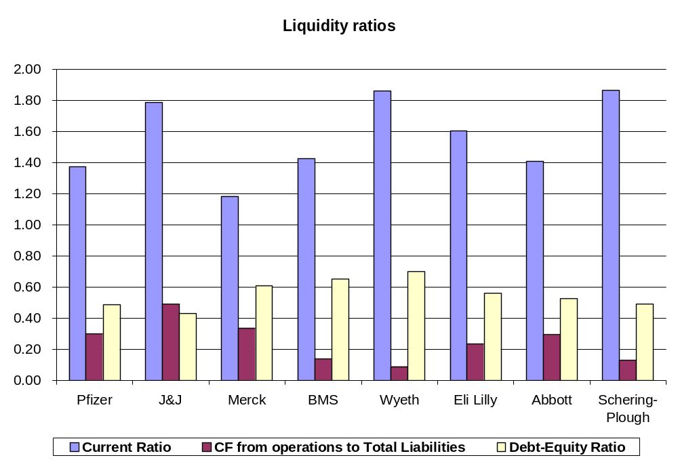

All companies have high enough level of Current Ratio, showing the ability of the company to cover its short-term liabilities with it current assets. At the same time several companies have Cash Flows from operations to Total Liabilities ratio at the level below 20% which is considered as a minimum safe level for financially healthy company. For Wyeth and Schering-Plough – companies that experienced significant reduction in profitability during the last years as it was mentioned above – the inability to satisfy long-term liquidity requirement is especially alarming.

Analysis of geographical distribution of sales in 2004 revealed that 7 out of 8 major U.S. pharmaceutical companies have more than 50% of their sales from the U.S. market; and only Schering-Plough in 2004 was the exception to this rule. Most important international markets for U.S. companies remain Japan and Western Europe.

Chart 2.2. Geographical distribution of sales, 2004

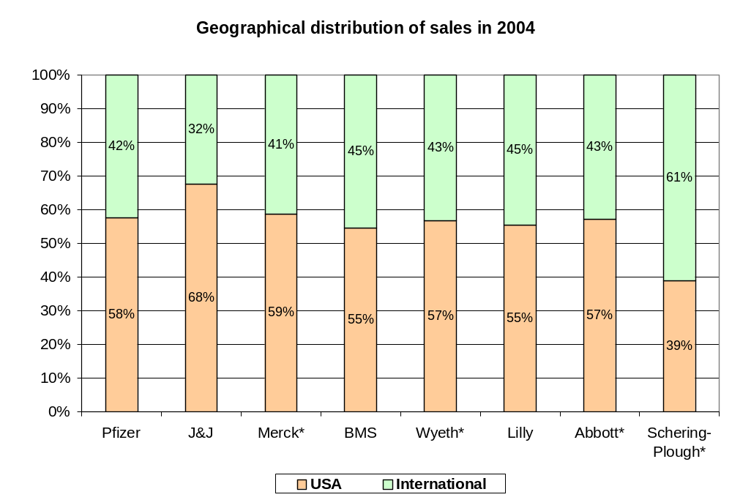
Source: Annual Reports of the companies
*No geographical distribution of pharmaceutical segment is available. Proportions calculated on geographical distribution of total sales.

Pharmaceutical companies outside the U.S.

Seven out of 15 largest pharmaceutical companies are headquartered outside of the U.S. : this is British GlaxoSmithKline and AstraZeneca, Swiss Novartis and Roche, French Sanofi-Aventis, Japanese Takeda and German Bayer.

There are two factors that make comparison of these 7 companies more complicated than that for US-based companies. First, these companies consolidate their financial statements using different currencies (see Table 2.9). Influence of currency exchange fluctuations is significant and in some cases complicates direct comparison of financial indicators. In this section all ratios were calculated on the basis of financial statements in original currencies; for comparison purposes in some cases financial indicators were also translated into US dollars.

Table 2.9. Currency used in annual reports by major non-US based pharmaceutical companies
Company | Currency used in consolidated annual reports
GlaxoSmithKline | British Pound
AstraZeneca | US dollar
Novartis | Swiss Frank before 2002 and US Dollar starting from 2002
Sanofi-Aventis | Euro
Roche | Swiss Frank
Takeda | Japanese Yen
Bayer | Euro

Secondly, companies headquartered in different countries use different national accounting standards which in some cases can give very different results. For example, recent merger of Astra and Zeneca is reported as a merger under UK GAAP, but has been accounted as acquisition of Astra by Zeneca under U.S. GAAP resulting in significant differences in financial statements of this company under these two accounting standards. So far as not all data is reported in U.S. GAAP in financial statement of the companies, to keep integrity of data financial reports in national standards were used for ratio calculations.

Table 2.10 summarizes major business segments of non-US based pharmaceutical companies calculated on the basis of 2004 sales.

Table 2.10. Business segments of major non-US pharmaceutical companies
 | GlaxoSmithKline | AstraZeneca¹ | Novartis² | Roche³ | Sanofi-Aventis⁴ | Takeda⁵ | Bayer
Pharmaceutical | 84.2% | 100.0% | 65.5% | 69.4% | 95.5% | 86.1% | 14.7%
Consumer Health & Nutritional products | 15.8% |  | 31.4% |  |  |  | 11.1%
Animal Health |  |  | 3.1% |  |  |  | 2.6%
Medical Devices and Diagnostics |  |  |  | 25.0% |  |  | 6.6%
Other Healthcare
Other |  |  |  | 5.6% | 4.5% | 13.9% | 65.0%
Source: Annual Reports of the companies
¹ Although AstraZeneca has minor non-pharmaceutical businesses (for example, Astra Tech is engaged in the R&D, manufacture and marketing of medical devices and implants), the company does not report any other business segments than pharmaceutical
² In financial statements Animal Health products are included in Consumer Health business segment
³ By ‘Other’ Roche reports results of discontinuing operations
⁴ Sanofi-Aventis reports two business segments: Pharmaceutical and Human vaccines (the latter one is shown in this table as ‘Other’).
⁵ Starting from 2003 Takeda reports both pharmaceutical and consumer healthcare businesses as Pharmaceutical segment. In 'Other' segment Takeda reports sales of vitamins, reagents, activated carbon and wood preservatives.

Business segment decomposition for non-US pharmaceutical companies is very similar to that of major US-based pharmaceutical companies. The pharmaceutical segment of almost all of these companies is the largest one; the only exception is Bayer pharmaceutical sales of which was just about 14.7% of total sales in 2004. AstraZeneca and Sanofi-Aventis, both of which underwent recent merger processes, almost totally concentrate their resources on pharmaceutical industry.

According to recent restructuring efforts of Japanese Takeda the company has a similar strategy of concentrating on almost exclusively the pharmaceutical segment: during the last few years Takeda sold a number of its non-pharmaceutical businesses (agricultural chemicals business, latex business, food business, numerous chemicals business) that increased its pharmaceutical segment share in total sales. Moreover, the company during last years significantly increased its level of outsourcing (from 30% in 2000 to about 65% in 2003). These moves allow Takeda to concentrate all its resources on the most profitable part of its business and are intended to increase the market share of the company on the world pharmaceutical market.

Roche and Novartis follow another strategy that assumes diversification of highly risky pharmaceutical business by other segments of Health Care industry: Novartis has about one third of its sales from the Consumer Health segment, and Roche has about one quarter of its sales from Medical Devices and Diagnostics business.

As mentioned above, German Bayer stands apart from all other companies presented in Table 2.10 with only 14.7% of its sales from pharmaceutical segment and 35% of its sales from all Health Care businesses. Besides the Health Care segment Bayer also works in Crop Science, Material Science and Chemical business segments. Because of extremely low share of its pharmaceutical segment it is difficult to call Bayer a pharmaceutical company; nevertheless, with total sales of about 30 billion euro even the small share of the pharmaceutical segment gives Bayer about 4.4 billion euro of revenues from sales of pharmaceuticals products.

As Table 2.11 shows, non-US pharmaceutical companies, in a similar way to U.S. companies, mainly concentrate their resources on areas with the highest market size – anti-bacterial / anti-infections, cardiovascular diseases, neurology / psychiatric disorders and oncology. Obviously, such giants as GlaxoSmithKline and Novartis with 2004 R&D expenditures of $5.2 and $4.2 billion respectively cover almost all areas, while companies with much lower levels of R&D spending, such as Takeda and Bayer with 2004 R&D expenditures of $1.2 and $2.6 billion respectively, concentrate on some specific areas.

Table 2.11. Major areas of focus of non-US pharmaceutical companies
 | GlaxoSmithKline | AstraZeneca | Novartis | Roche | Sanofi-Aventis | Takeda | Bayer
Anti-bacterial / anti-fungal / infections | X | X | X | X | X |  | X
Anti-inflammatory / anagletics | X | X |  | X
Cardiovascular diseases | X | X | X | X | X | X | X
Dermatology | X |  | X | X
Eye diseases |  |  | X
Gastrointestinal | X | X | X |  |  | X
Hematology |  |  | X
Immunology |  |  | X
Metabolic diseases | X |  | X | X | X
Neurology / psychiatric disorders | X | X | X | X | X | X
Oncology | X | X | X | X | X | X | X
Respiratory diseases | X | X | X |  | X
Urogenital conditions | X |  | X |  | X | X | X
Virology (including HIV) | X |  |  | X
Source: Annual Reports of the companies

Sales and total assets dynamics of 7 major non-US pharmaceutical companies are provided in Tables 2.12 and 2.13. Three major factors that determine the dynamics of these parameters – mergers / acquisitions, R&D expenditures, and ability of companies to protect their patents – are briefly discussed below to give a better understanding of sales and total assets dynamics.

Table 2.12. Sales dynamics of non-US pharmaceutical companies, 2002-2004
 | 2002 | 2003 | 2004
GlaxoSmithKline | 3.5% | 1.1% | -5.0%
AstraZeneca | 10.0% | 5.6% | 13.7%
Novartis | 11.3% | 19.1% | 13.6%
Roche | 1.0% | 6.0% | 0.2%
Sanofi-Aventis | 14.8% | 8.1% | 86.9%
Takeda | 4.3% | 4.1% | 3.9%
Bayer | -2.2% | -3.6% | 4.2%
Source: calculations, data used from Annual Reports of the companies

Table 2.13. Total assets dynamics of non-US pharmaceutical companies, 2002-2004
 | 2002 | 2003 | 2004
GlaxoSmithKline | -0.1% | -5.0% | 6.5%
AstraZeneca | 16.7% | 9.3% | 8.7%
Novartis | 13.3% | 9.5% | 10.4%
Roche | -15.0% | -7.0% | -2.4%
Sanofi-Aventis | -5.1% | 3.1% | 687.3%
Takeda | 12.4% | 4.8% | 13.4%
Bayer | 12.6% | -10.2% | 1.0%
Source: calculations, data used from Annual Reports of the companies

As it was mentioned above, the largest and most attractive market for pharmaceutical companies is the United States. Therefore, companies with head-quarters outside of the U.S. need to spend extra resources in order to successfully compete with US-based companies on their territory. As the result, consolidation of the pharmaceutical industry outside of the U.S. during the last few years was even stronger than in the U.S. : three out of seven major non-US based pharmaceutical companies, GlaxoSmithKline, AstraZeneca and Sanofi-Aventis, recently underwent the process of mergers.

GlaxoSmithKline was formed as the result of the merger of Glaxo Wellcome and SmithKline Beecham in 2000. Among major reasons of this merger were named enhanced marketing power, improved R&D productivity and increased financial strength. GlaxoSmithKline is now the largest pharmaceutical company outside the U.S. and the second largest worldwide. At the same time, restructuring initiatives that followed the merger had a negative impact on its sales during next several years after the merger took place.

Similar factors lead to the merger of Astra and Zeneca in 1999 to form AstraZeneca, the 5th largest pharmaceutical company worldwide according to 2004 sales from the pharmaceutical business segment. It is worth mentioning that in both cases the companies had to spend significant resources and time to utilize synergies of theses mergers. For example, according to 2002 annual report of AstraZeneca, it took 2 years and about $1.4 billion in order to consolidate the operations and remove duplicate activities of different units of the newly formed company.

High rates of consolidation in the industry were one of the factors that lead to another significant merger: in 2004 Sanofi-Aventis finished its registration as the result of the merger of Sanofi-Synthelabo and Aventis. The results of operations of Aventis for the period between August 20, 2004 and December 31, 2004 have been included in the consolidated financial statements that resulted in a significant increase in revenues and total assets shown in Tables 2.12 and 2.13.

Other non-US pharmaceutical companies also tried to strengthen their positions by acquiring other companies according to their strategy. Novartis and Roche, both of each do not concentrate exclusively on the pharmaceutical industry, further diversified their businesses by acquiring non-pharmaceutical companies. Bayer’s current acquisitions (seed treatment business and over-the-counter medicines) even further decreased its share of pharmaceutical segment. Major acquisitions of non-US pharmaceutical companies are summarized in Table 2.14.

Table 2.14. Recent acquisitions by major non-US pharmaceutical companies
Company | Company acquired* | Core business of target | Purchase price
GlaxoSmithKline | Merger of Glaxo Wellcome and SmithKline Beecham | Megrer of two major pharmaceutical companies (registered in 2000) | -
GlaxoSmithKline | Block Drug | Oral care and over-the-counter medicines | 843 mln GBP
AstraZeneca | Merger of Astra and Zeneca | Megrer of two major pharmaceutical companies (registered in 1999) | -
Novartis | Sabex | Generic manufacturer with a leading position in generic injectables | 565 mln USD
Novartis | Mead Johnson's adult nutrition business | Global adult medical nutrition | 385 mln USD
Novartis | Idenix Pharmaceuticals Inc | Biotechnology | 255 mln USD + up to 357 mln USD in possible additional payments
Roche | Igen International | Human in-vitro diagnostics | 1,823 mln CHF
Roche | Disetronic | Insulin pumps and injection systems for the treatment of diabetes. | 1,132 mln CHF
Sanofi-Aventis | Merger of Sanofi-Synthelabo and Aventis | Merger of two major pharmaceutical companies (registered in 2004) | -
Bayer | Roche's over-the-counter business | Over-the-counter medicines | 206 mln EUR
Bayer | Gustafson | Seed treatment | 100 mln EUR
Source: Annual Reports of the companies
*Acquisition of patents is not included in this table

Overall, as shown in Table 2.15, non-US pharmaceutical companies have approximately similar R&D costs as % of total sales to those of U.S. companies.

Several comments should be made. First, the incredible 49.6% for Sanofi-Aventis is explained mainly by current merger of Sanofi-Synthelabo and Aventis – according to accounting standards in-progress R&D costs of Aventis were capitalized after its acquisition. During three years preceding this merger the company annually spent about 16.2% of its sales for R&D.

Second, very low values of R&D costs as % of total sales for Bayer to a significant extent can be explained by a very low share of pharmaceutical business in its total sales.

Finally, Takeda has the goal of becoming one of the leading pharmaceutical companies worldwide. Recent restructuring initiatives of the company that were mentioned above allow Takeda to concentrate its resources mainly on development of new drugs that had the reflection in increase of its R&D expenditures as % of total sales from 9.3% in 2001 to 11.9% in 2004.

If we do not count capitalized R&D expenditures of Sanofi-Aventis, GlaxoSmithKline was the leader in 2004 R&D expenditures in absolute terms (about $5.2 million), while AstraZeneca had the best result in relative terms (average of 17.6% during last 4 years).

Table 2.15. R&D costs as % of 2004 total sales
 | 2001 | 2002 | 2003 | 2004
GlaxoSmithKline | 12.5% | 12.9% | 12.9% | 13.9%
AstraZeneca | 17.1% | 17.2% | 18.3% | 17.7%
Novartis | 13.5% | 13.6% | 15.1% | 14.9%
Roche | 13.3% | 14.5% | 15.3% | 16.3%
Sanofi-Aventis | 15.9% | 16.4% | 16.4% | 49.6%
Takeda | 9.3% | 10.0% | 11.9% | 11.9%
Bayer | 8.5% | 8.7% | 8.4% | 7.1%
Source: Annual Reports of the companies
To calculate this ratio R&D costs and revenues for all business segments of the company were used

As it was discussed above, after expiration of its patent, drugs usually experience very sharp decline in their sales. Therefore, companies with a well balanced portfolio of their products with no any single product having very high share of sales can be considered as less risky. From this point of view non-US pharmaceutical companies look better. As Table 2.16 shows for all listed companies the share of the best-selling product is below 20% while three US-based companies exceed this level (Pfizer’s Lipitor has 20.7% of sales, Merck’s Zocor has 22.7%, and Eli Lilly’s Zyprexa has 31.9%) and two other companies are very close to this threshold (Wyeth’s Effexor has 19.3% of sales, and BMS’s Plavix has 17.2% of sales).

Expiration of patents had a significant negative effect on some of non-US pharmaceutical companies during last several years. For example, negative effect of generic competition to GlaxoSmithKline’s Paxil and Wellburtin was estimated to be 1.5 billion GBP (about $2.7 billion) that was one of the major factors that caused decline in sales of the company by 5%.

Another example is the expiration of Bayer’s Cipro patent that caused a 41% decline in sales of this Bayer’s top selling product.

Table 2.16. Top 5 pharmaceutical products based on the sales in 2004
GlaxoSmithKline | Sales, mln GBP | % of total sales | Sales, mln USD |  | Roche | Sales, mln CHF | % of total sales | Sales, mln USD
Seretide / Advair | £2,461 | 12.1% | $4,512 |  | MabThera / Rituxan | CHF 3,378 | 10.8% | $2,719
Avandial / Avandamet | £1,116 | 5.5% | $2,046 |  | NeoRecormon, Epogin | CHF 2,082 | 6.7% | $1,676
Paxil | £1,063 | 5.2% | $1,949 |  | Pegasys + Copegus | CHF 1,562 | 5.0% | $1,257
Zofran | £763 | 3.7% | $1,399 |  | Herceptin | CHF 1,435 | 4.6% | $1,155
Wellbutrin | £751 | 3.7% | $1,377 |  | CellCept | CHF 1,403 | 4.5% | $1,129
AstraZeneca | Sales, mln USD | % of total sales |  |  | Sanofi-Aventis | Sales, mln EUR | % of total sales | Sales, mln USD
Nexium | $3,883 | 18.1% |  |  | Lovenox | € 1,904 | 12.7% | $2,368
Seroquel | $2,027 | 9.5% |  |  | Plavix | € 1,694 | 11.3% | $2,107
Losec / Prilosec | $1,947 | 9.1% |  |  | Allegra | € 1,502 | 10.0% | $1,868
Seloken | $1,387 | 6.5% |  |  | Taxotere | € 1,436 | 9.5% | $1,786
Pulmicort | $1,050 | 4.9% |  |  | Stilnox | € 1,423 | 9.5% | $1,770
Novartis | Sales, mln USD | % of total sales |  |  | Bayer | Sales, mln EUR | % of total sales | Sales, mln USD
Diovan / Co-Diovan | $3,093 | 10.9% |  |  | Ciprobay / Cipro | € 837 | 2.8% | $1,041
Gleevec/Glivec | $1,634 | 5.8% |  |  | Adalat | € 670 | 2.3% | $833
Lamisil | $1,162 | 4.1% |  |  | Ascensia | € 627 | 2.1% | $780
Zometa | $1,078 | 3.8% |  |  | Aspirin | € 615 | 2.1% | $765
Neoral / Sandimmun | $1,011 | 3.6% |  |  | Kogenate | € 563 | 1.9% | $700
Source: Financial reports of the companies
Sales are provided in the currency of financial reports; conversion of sales into USD was made for comparison purposes

As for the case of U.S. pharmaceutical companies we calculated profitability and liquidity ratios for non-US pharmaceutical companies (provided in Table 2.17 and chart 2.3 respectively). Several factors are worth mentioning.

First, both GlaxoSmithKline and AstraZeneca that underwent large-scale merger processes showed pretty stable financial performance during the last few years that indirectly says something positive about successful completion of their restructuring initiatives. It is too early to make any conclusions regarding the results of the merger of Sanofi-Synthelabo and Aventis. Although the company reported -8.3% ROA in 2004 in comparison with 21.6% during the previous year this sharp decline is mainly caused by accounting treatment of transactions related to the merger: expensing total acquired R&D of Aventis (total negative effect of 5,046 million EUR), and accounting of inventories (total negative effect of 342 million EUR after tax).

Second, losses of Roche 2002 to a significant extent can be explained by the legal settlements with U.S. direct customers in the vitamin case, as well as sale of the Vitamins and Fine Chemicals Division.

Finally, Bayer showed much lower results than other companies in this group. Partially this can be explained by much lower share of the highly profitable pharmaceutical business in its total sales.

Table 2.17. Profitability analysis
 | 2002 | 2003 | 2004
GlaxoSmithKline
ROA | 17.6% | 20.6% | 19.7%
Profit margin | 18.5% | 20.9% | 21.1%
Total Assets Turnover Ratio | 0.95 | 0.99 | 0.93
AstraZeneca
ROA | 14.2% | 13.4% | 15.5%
Profit margin | 15.9% | 16.1% | 17.8%
Total Assets Turnover Ratio | 0.89 | 0.83 | 0.87
Novartis
ROA | 11.1% | 10.6% | 11.1%
Profit margin | 22.6% | 20.2% | 20.4%
Total Assets Turnover Ratio | 0.49 | 0.53 | 0.54
Roche
ROA | -5.8% | 5.0% | 11.3%
Profit margin | -13.7% | 9.8% | 21.2%
Total Assets Turnover Ratio | 0.42 | 0.51 | 0.53
Sanofi-Aventis
ROA | 18.1% | 21.6% | -8.3%
Profit margin | 23.6% | 25.8% | -24.0%
Total Assets Turnover Ratio | 0.77 | 0.84 | 0.35
Takeda
ROA | 12.5% | 13.5% | 13.0%
Profit margin | 23.1% | 26.0% | 26.3%
Total Assets Turnover Ratio | 0.54 | 0.52 | 0.49
Bayer
ROA | 2.7% | -3.4% | 1.6%
Profit margin | 3.6% | -4.8% | 2.0%
Total Assets Turnover Ratio | 0.75 | 0.72 | 0.79
Source: calculations, data used from Annual Reports of the companies

Analysis of liquidity ratios shows that on average companies that recently underwent the merger process have higher Debt-Equity Ratio than others. For example, this ratio for Sanofi-Aventis jumped from 0.35 before the merger to 0.53 at the year of the merger. Such significant increasess of debt can be explained by two major factors: a) company incurred a new debt to finance the cash portion of the acquisition consideration, b) consolidated financial debt includes the debt incurred by Aventis prior to acquisition.

It is also interesting to compare European and Asian business models: Takeda, the only Asian country in this group, showed the lowest debt-equity ratio (0.25) that is much lower than average 0.48 for the whole group.

Chart 2.3. Liquidity analysis

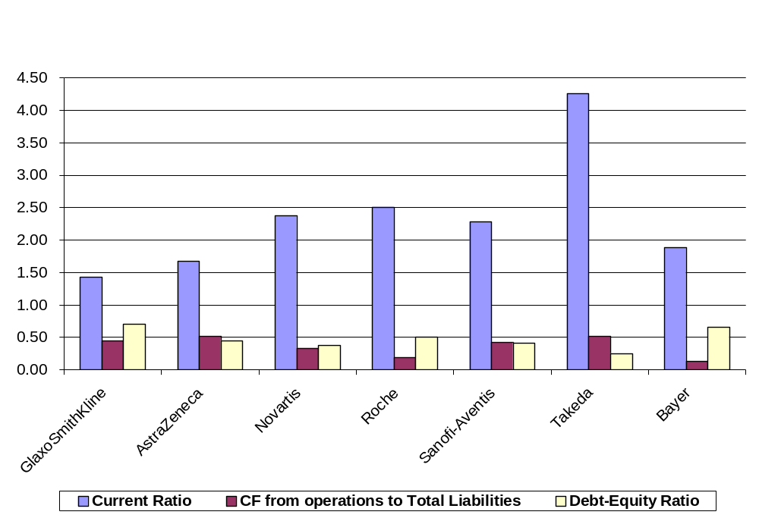

Not surprisingly, for non-US pharmaceutical companies it is much more difficult to gain access to the U.S. pharmaceutical market that remains the largest and the most attractive market worldwide. While almost all U.S. pharmaceutical companies had more than 50% of their sales from the U.S. market, none of non-US companies could claim as much as 50% of the revenues from it. At the same time, it is worth mentioning that for three largest non-US companies (GlaxoSmithKline, AstraZeneca and Novartis) the U.S. represented the largest geographical segment.

From the point of view of geographical distribution of sales Takeda remained apart from all other companies – it had more than 50% of its sales from non-US and non-European markets (mainly from Japanese market).

Chart 2.4. Geographical distribution of sales, 2004

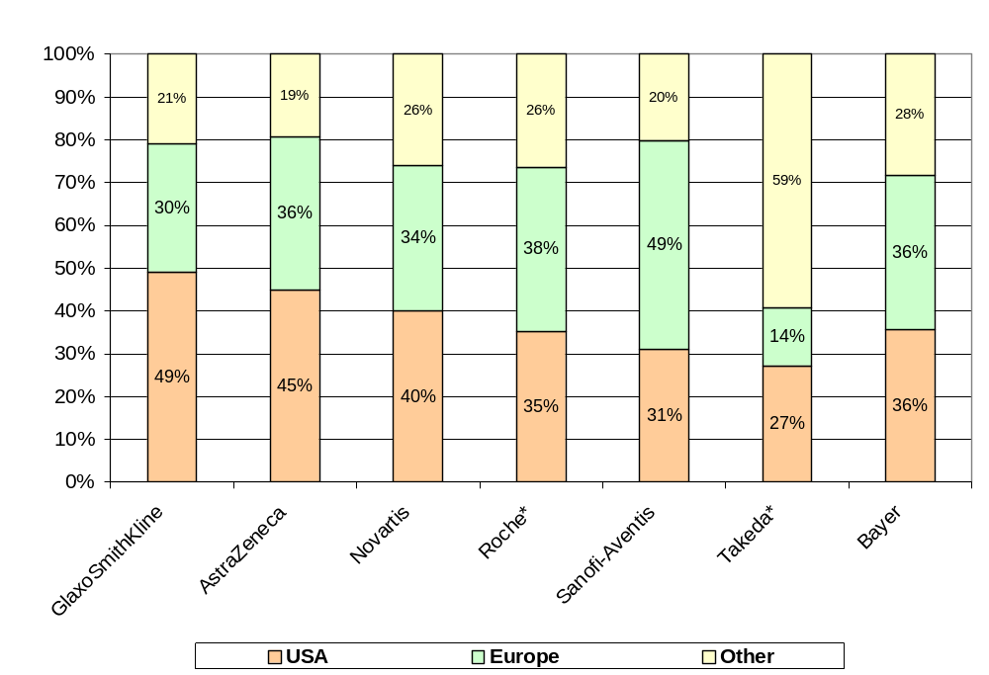

Source: Annual reports of the companies

* No geographical distribution of pharmaceutical segment is available. Proportions calculated on the basis of geographical distribution of total sales.

Part 3. Summary

Indiana is home to Eli Lilly and is the location of several other pharmaceutical manufacturing companies. These companies contribute significantly to Indiana’s domestic and international profile. The good news is that that these companies – like the rest of the industry – are doing well and share in a sanguine outlook. Demographics and rising incomes in industrial and developing countries combine to promise rapidly growing future sales.

But the gains for any particular company are not guaranteed. Drug companies compete vigorously – with themselves, generic producers, and with related-health companies who want a share of their action. The industry is changing fast. To survive and to prosper involves managing drug pipelines – as drugs come off patents they no longer bring in enough revenues and must be replaced quickly by other drugs with durable patents. This means that the companies have to think ahead, something that sounds easy but involves great risks. Huge sums must be invested in uncertain in-house research and development and/or must go toward mergers and acquisitions with other promising companies. Strategic alliances can be used to augment opportunities as well.

As companies develop their new pipelines they must be mindful of changes caused by regulations and deregulations in countries all over the globe. While most of drug consumption and sales is a U.S.-European-Japanese affair – deregulation means sales opportunities are growing rapidly in the developing world. China, Thailand, Egypt, Mexico, Argentina, Brazil, and Venezuela have been increasing their imports of pharmaceuticals products at rapid rates. Of course, where there is growing demand – there is also growing supply and competition. Many new drug companies are springing up in developing countries and the biggest global firms are moving into those territories. But even this has more than the usual global risk for drug companies because of the importance of intellectual property protection. Picking places and partners takes more than the usual scrutiny or a company can lose valuable resources. Speaking of places – we noted that the U.S. is the largest market for pharmaceutical sales – and therefore will continue to be a hotbed of competition for Lilly and the other U.S. producers. Non-U.S. companies have been very active in mergers and acquisitions and will be more formidable competitors on U.S. soil.

This global competitive environment creates challenges and opportunities for the companies – with equal importance for the communities in which they reside. If size matters in the drug industry then both domestic and foreign mergers, acquisitions, and strategic alliances will continue to be critical. Such changes always have implication for location requiring communities around the globe to think harder about their roles as globalization unfolds. Communities that desire to maintain or build pharmaceutical clusters must be mindful that investment is always a two-way street. Building strong and growing pharmaceutical clusters at home will entail both inbound and outbound investment since whatever companies locate or stay in their areas – they will be compelled by global competition to own production facilities abroad.

This research offers no new insights into what it takes to build a viable pharmaceutical cluster but it surely underlines two facts – that it is worth doing in Indiana and that it will involve retaining and attracting companies that need to take sizeable financial risks. This suggests an infrastructure that supports not only the usual needs for top flight talent and communications/transportation advantages – but it suggests an environment that allows for flexibility and risk taking. While clusters bring to mind new facilities and higher employment, global competition suggests that drug companies will survive and prosper sometimes by shedding unprofitable lines of business. It is always painful for any community when firms restructure. It is tempting to regulate firms so that the blows to the community are softer. But the truth of the drug industry is that competitiveness and growth will require many actions on the parts of these firms – and not all of them will seem to be in the best short-run interest of the community.

References

1. (Abbott Laboratories Annual Report 2002)
http://abbott.com/investor/2002annualreport/downloads/abbott2002ar.pdf

2. (Abbott Laboratories Annual Report 2003)
http://abbott.com/investor/2003annualreport/2003AnnualReport.pdf

3. (Abbott Laboratories Annual Report 2004)
http://abbott.com/investor/2004annualreport/includes/abbott_ar04_full.pdf

4. (Agarwal Sumit, Desai Sanjay, Holcomb Michele, Oberoi Arjun, “Unlocking the Value in Big Pharma)
The McKinsey Quarterly, 2001 Number 2

5. (AstraZeneca Annual Report 2002)
http://www2.astrazeneca.com/annualrep2002/pdf/AZ%20ENG_Report.pdf

6. (AstraZeneca Annual Review 2002)
http://www2.astrazeneca.com/annualrep2002/pdf/AstraZeneca_Review_2002.pdf

7. (AstraZeneca Annual Review 2003)
http://www.astrazeneca.com/sites/7/imagebank/typearticleparam503063/A_Review_2003_English.pdf

8. (AstraZeneca Annual Report 2003)
http://www.astrazeneca.com/sites/7/imagebank/typearticleparam503063/AstraZeneca%20Annual%20Report%202003.pdf

9. (AstraZeneca Annual Report 2004)
http://www.astrazeneca.com/sites/7/imagebank/typearticleparam511562/astrazeneca-2004-annual-report.pdf

10. (AstraZeneca Annual Review 2004)
http://www.astrazeneca.com/sites/7/imagebank/typearticleparam511562/astrazeneca-2004-annual-review.pdf

11. (Bayer Annual Report 2002)
http://www.investor.bayer.com/docroot/_files/berichte1032356037/geschftsberichte1032356052/gb_2002_e1047539476.pdf

12. (Bayer Annual Report 2003)
http://www.investor.bayer.com/docroot/_files/berichte1032356037/geschftsberichte1032356052/gb_2003_e1086944359.pdf

13. (Bayer Annual Report 2004)
http://www.investor.bayer.com/docroot/_files/berichte1032356037/geschftsberichte1032356052/gb_2004_e1110868599.pdf

14. (Bristol-Myers Squibb Annual Report 2002)
http://www.shareholder.com/bmy/edgar.cfm?PageNum=3&DocType=&SortOrder=Date%20Descending&Year=2003#

15. (Bristol-Myers Squibb Annual Report 2003)
http://www.bms.com/static/annual/2003ar/annual_report/data/2003bmsar.pdf

16. (Bristol-Myers Squibb Annual Report 2004)
http://www.shareholder.com/bmy/edgar.cfm?Year=2005&DocType=#

17. (Bristol-Myers Squibb Sales and Earnings Report 2004)
http://www.bms.com/static/irdocs/4q04fax.xls

18. (Eli Lilly Annual Report 2002)
http://lilly.com/investor/annual_report/lillyar2002complete.pdf

19. (Eli Lilly Annual Report 2003)
http://www.lilly.com/investor/annual_report/lillyar2003complete.pdf

20. (Eli Lilly Annual Report 2004)
http://www.lilly.com/investor/annual_report/lillyar2004complete.pdf

21. (GlaxoSmithKline Annual Report 2002)
http://www.gsk.com/financial/reps02/annual-review-02/cautionary-report.htm

22. (GlaxoSmithKline Annual Review 2002)
http://www.gsk.com/financial/reps02/annual-review-02/index.htm

23. (GlaxoSmithKline Annual Report 2003)
http://www.gsk.com/financial/reps03/annual_report2003.pdf

24. (GlaxoSmithKline Annual Review 2003)
http://www.gsk.com/financial/reps03/annual_review2003.pdf

25. (GlaxoSmithKline Annual Report 2004)
http://www.gsk.com/financial/reps04/annual-report-2004.pdf

26. (GlaxoSmithKline Annual Review 2004)
http://www.gsk.com/financial/reps04/annual-review-2004.pdf

27. (Johnson & Johnson Annual Report 2002)
http://www.investor.jnj.com/downloads/jnj_2002annual.pdf

28. (Johnson & Johnson Annual Report 2003)
http://www.investor.jnj.com/downloads/jnj_2003annual.pdf

29. (Johnson & Johnson Annual Report 2004)
http://www.investor.jnj.com/downloads/2004annual.pdf

30. (Johnson & Johnson Financial Review)
http://www.investor.jnj.com/downloads/2003_Financial_Review.pdf

31. (Johnson & Johnson Supplementary Sales Data 4Q 2004)
http://www.jnj.com/news/jnj_news/pdf/su404b5s4l9c2.pdf

32. (Merck Annual Report 2002)
http://www.merck.com/finance/annualreport/ar2002/merck_financial_section.pdf

33. (Merck Annual Report 2003)
http://www.merck.com/finance/annualreport/ar2003/financial_section/merck2003_ar_financials.pdf

34. (Merck Annual Report 2004)
http://www.merck.com/finance/annualreport/ar2004/pdf/Merck_2004_AR_FinSec.pdf

35. (National Science Foundation, “Research and Development in Industry: 2001”, 2001)

36. (O’Neill Jim, McCann Brian, George Mark, „The New Medicare Prescription Law”)
TS Insight, Volume 1 No 6, May 7, 2004

37. Pharmaceutical Research and Manufacturers of America (PhRMA).
“Pharmaceutical Industry Profile 2004” (Washington, DC: PhRMA, 2004)

38. (Pfizer Financial Report 2002)
http://www.pfizer.com/download/investors/financial/10k_0327_2003.pdf

39. (Pfizer Financial Report 2003)
http://www.pfizer.com/are/investors_reports/annual_2003/financial2003.pdf

40. (Pfizer Financial Report 2004)
http://www.pfizer.com/annualreport/2004/financial/financial2004.pdf

41. (Pfizer Annual Review 2004)
http://www.pfizer.com/annualreport/2004/annual/review2004.pdf

42. (Roche Annual Report 2002)
http://www.roche.com/pages/downloads/investor/pdf/reports/gb02/gb02e.pdf

43. (Roche Annual Report 2003)
http://www.roche.com/pages/downloads/investor/pdf/reports/gb03/gb03e.pdf

44. (Roche Annual Report 2004)
http://www.roche.com/pages/downloads/investor/pdf/reports/gb04/gb04e.pdf

45. (Sanofi-Aventis Annual Report 2002)
http://en.sanofi-aventis.com/Images/44_22402.pdf

46. (Sanofi-Aventis Annual Report 2003)
http://en.sanofi-aventis.com/Images/44_23523.pdf

47. (Schering Annual Report 2004)
http://www.schering.de/html/en/50_media/download/_files/2004/fin_rep/annual/04GB_en.pdf

48. (Schering-Plough Annual Report 2002)
http://media.corporate-ir.net/media_files/IROL/89/89839/reports/2002ar.pdf

49. (Schering-Plough Annual Report 2003)
http://media.corporate-ir.net/media_files/irol/89/89839/reports/2003ar.pdf

50. (Schering-Plough Annual Report 2004)
http://media.corporate-ir.net/media_files/IROL/89/89839/reports/sgp_ar04a.pdf

51. (Takeda Annual Report 2002)
http://www.takeda.com/english/annual/ar2002/pdf/ar2002.pdf

52. (Takeda Annual Report 2003)
http://www.takeda.com/english/annual/ar2003/pdf/ar2003.pdf

53. (Takeda Annual Report 2004)
http://www.takeda.com/english/annual/ar2004/pdf/ar2004.pdf

54. (Wyeth Annual Report 2003)
http://media.corporate-ir.net/media_files/irol/78/78193/reports/AR03/WyethAR03.pdf

55. (Wyeth Annual Report 2004)
http://library.corporate-ir.net/library/78/781/78193/items/141903/AR04.pdf

